**Week 6**

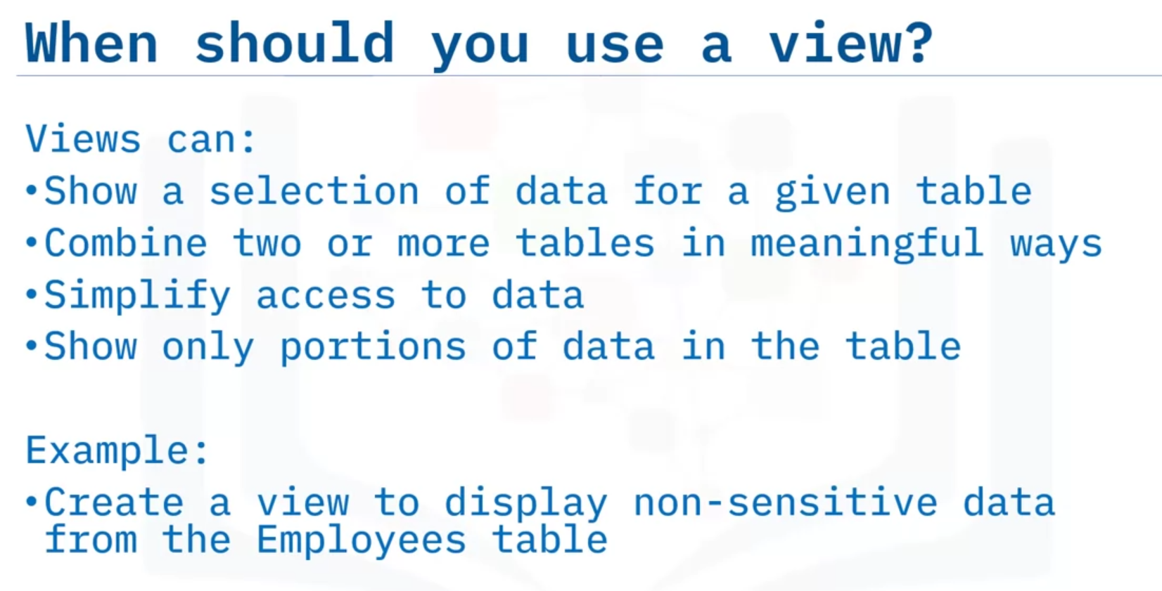

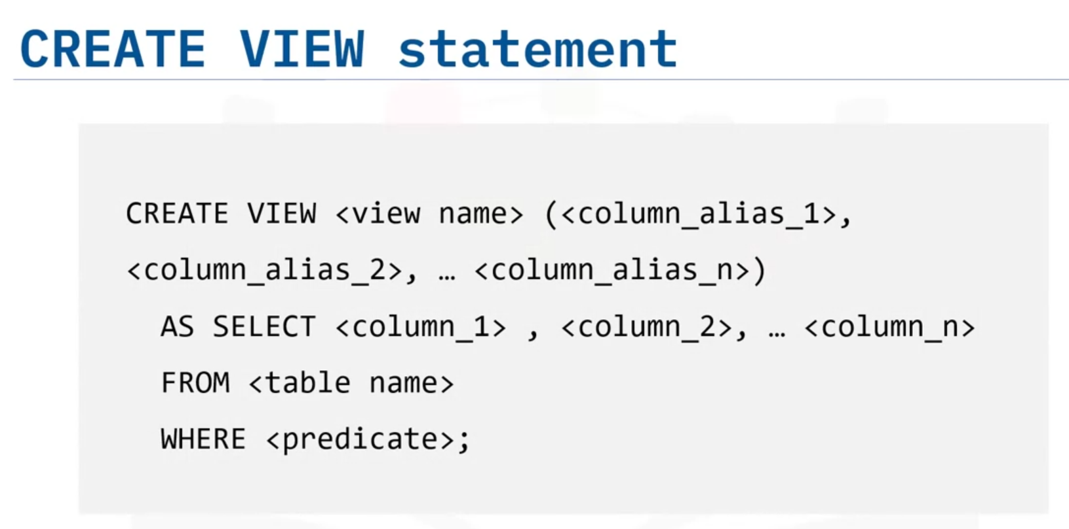

Как в питоне ты такой Х равно тому-то, то и здесь EMPINFO это такие-то колонки (имена именно колонок), а дальше указываешь запрос и там уже именно колонки указываешь.

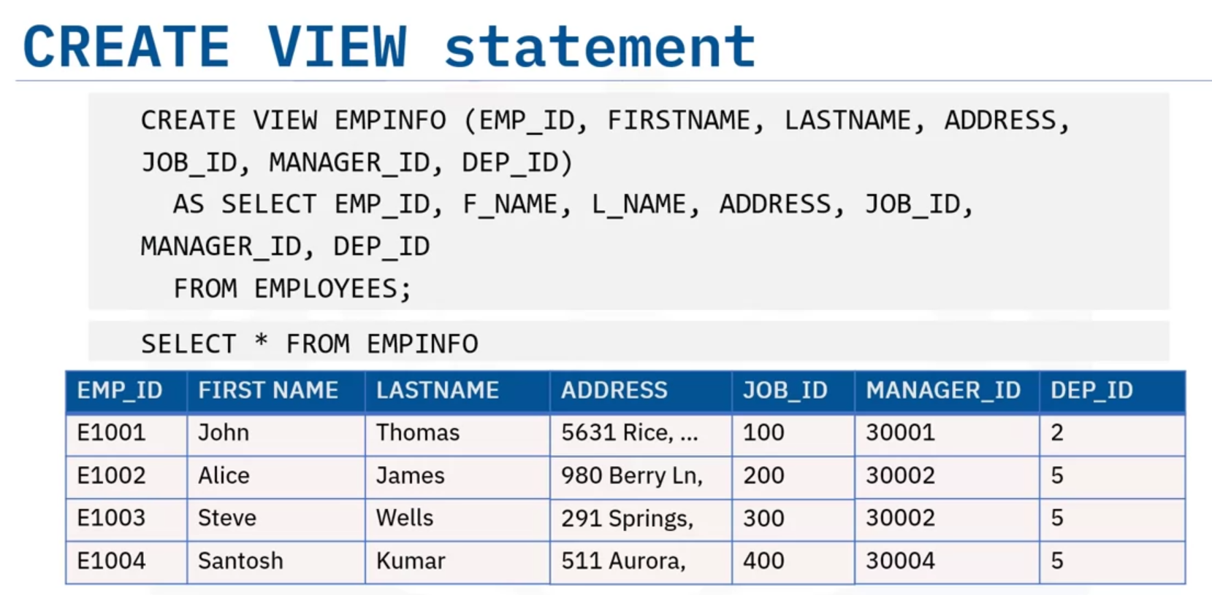

The SELECT statement that you use to create the view can name other views and tables,

and it can use the WHERE, GROUP BY, and HAVING clauses.

It cannot use the ORDER BY clause or name a host variable.

Example including WHERE:

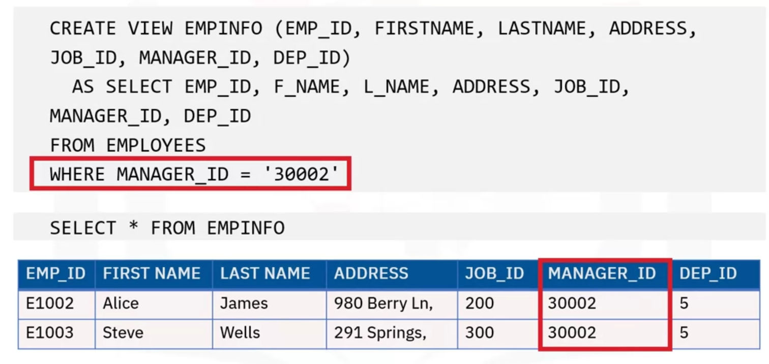

To remove a view:



Summary:

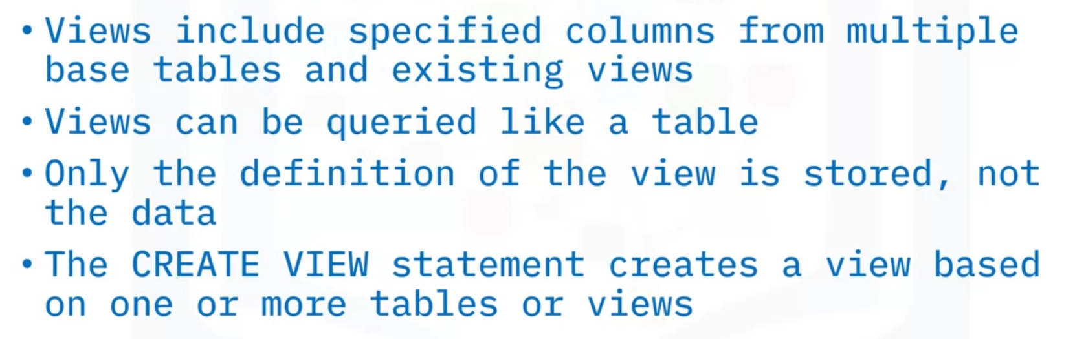

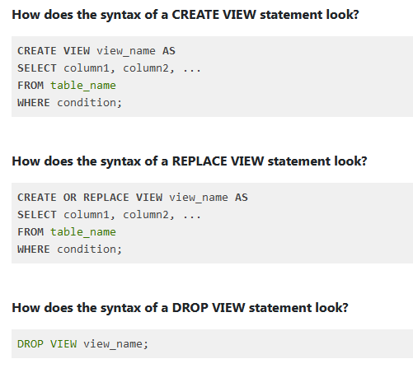

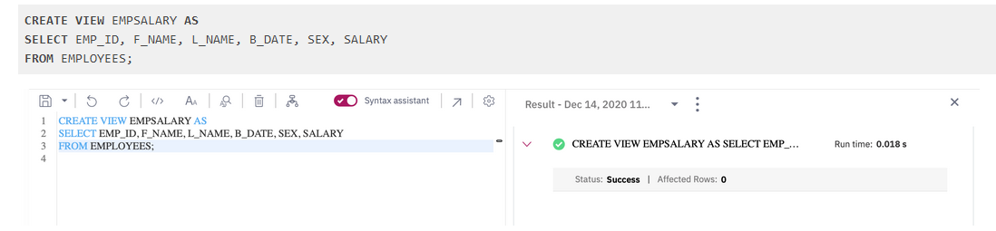

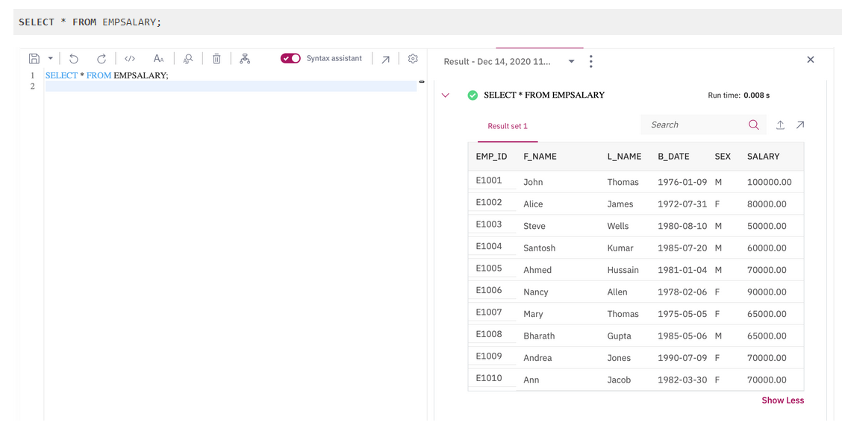

Update a view:

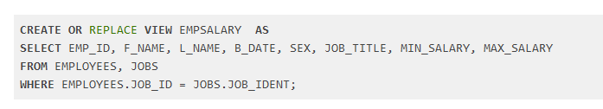

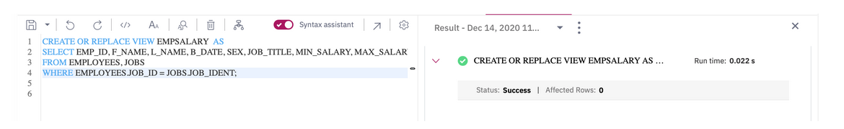

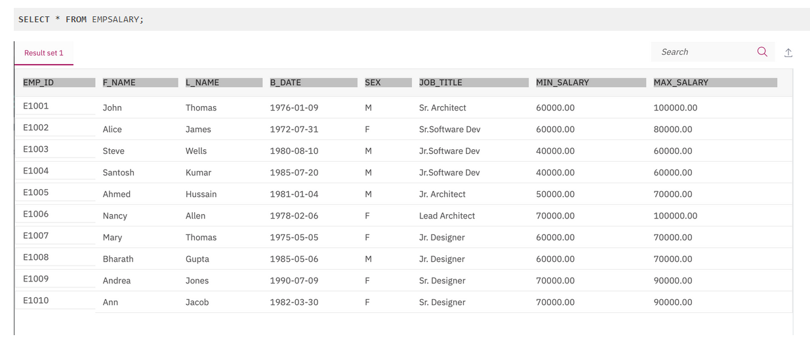

Delete a view:

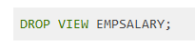

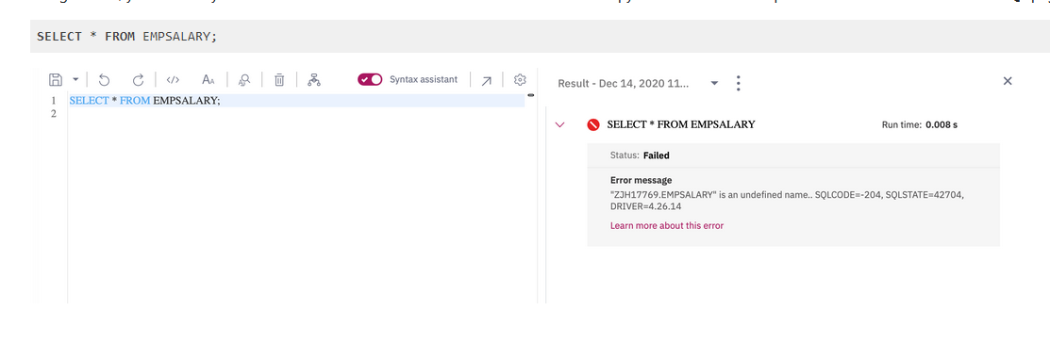

**Stored procedures**

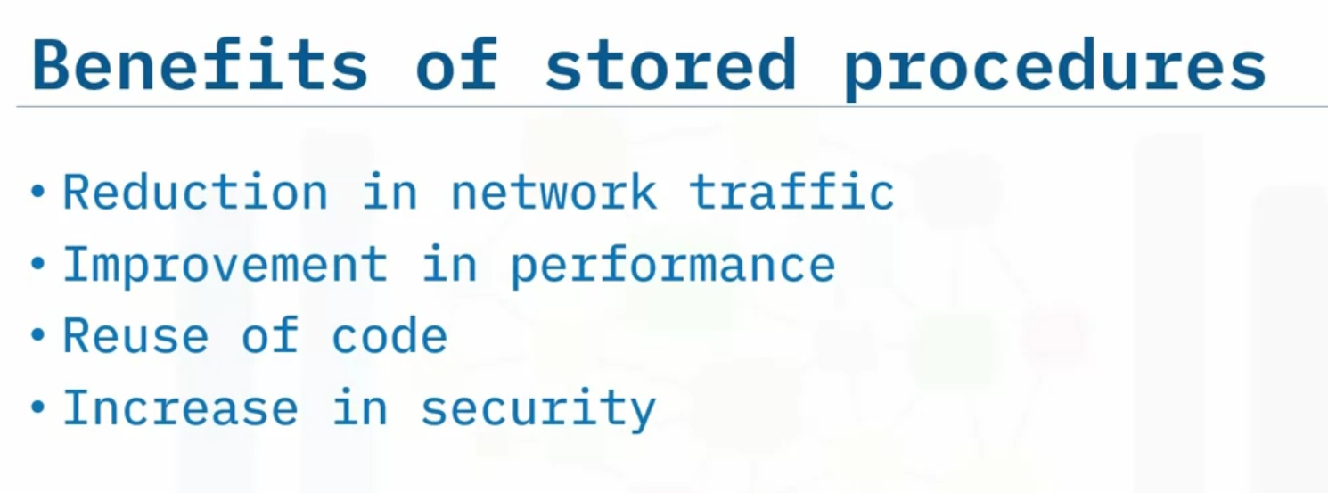

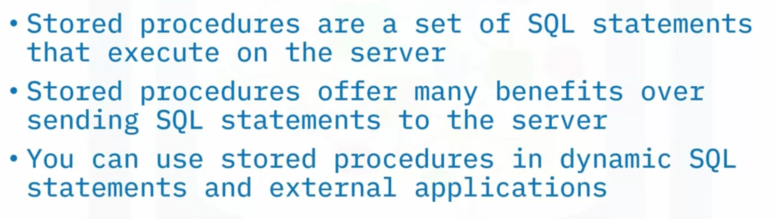

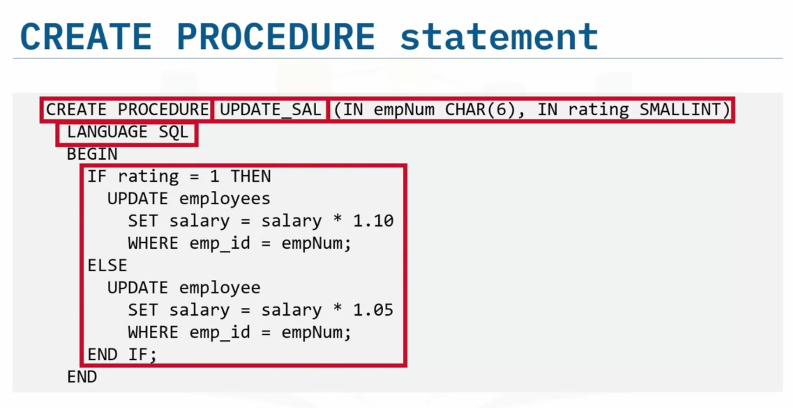

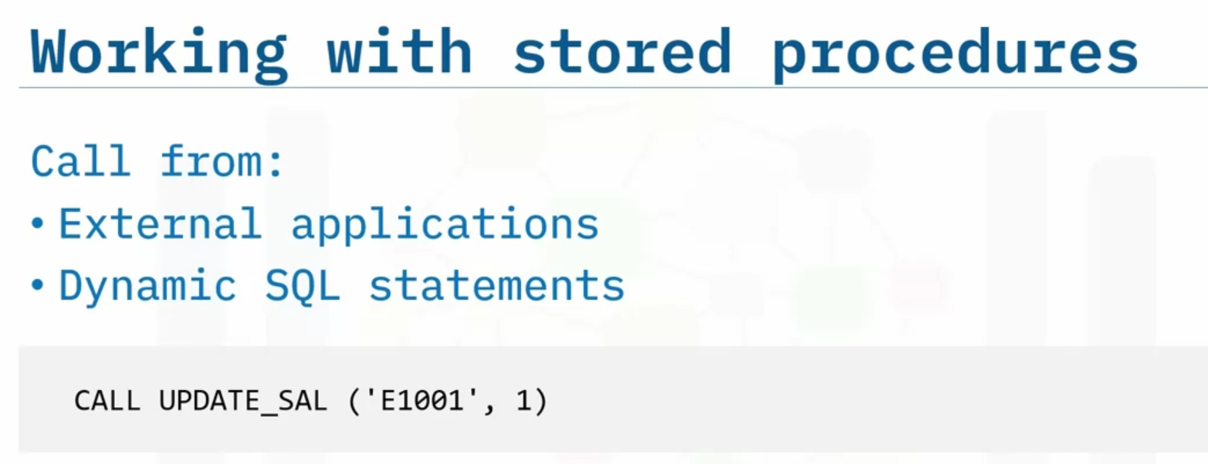

**ACID transactions**

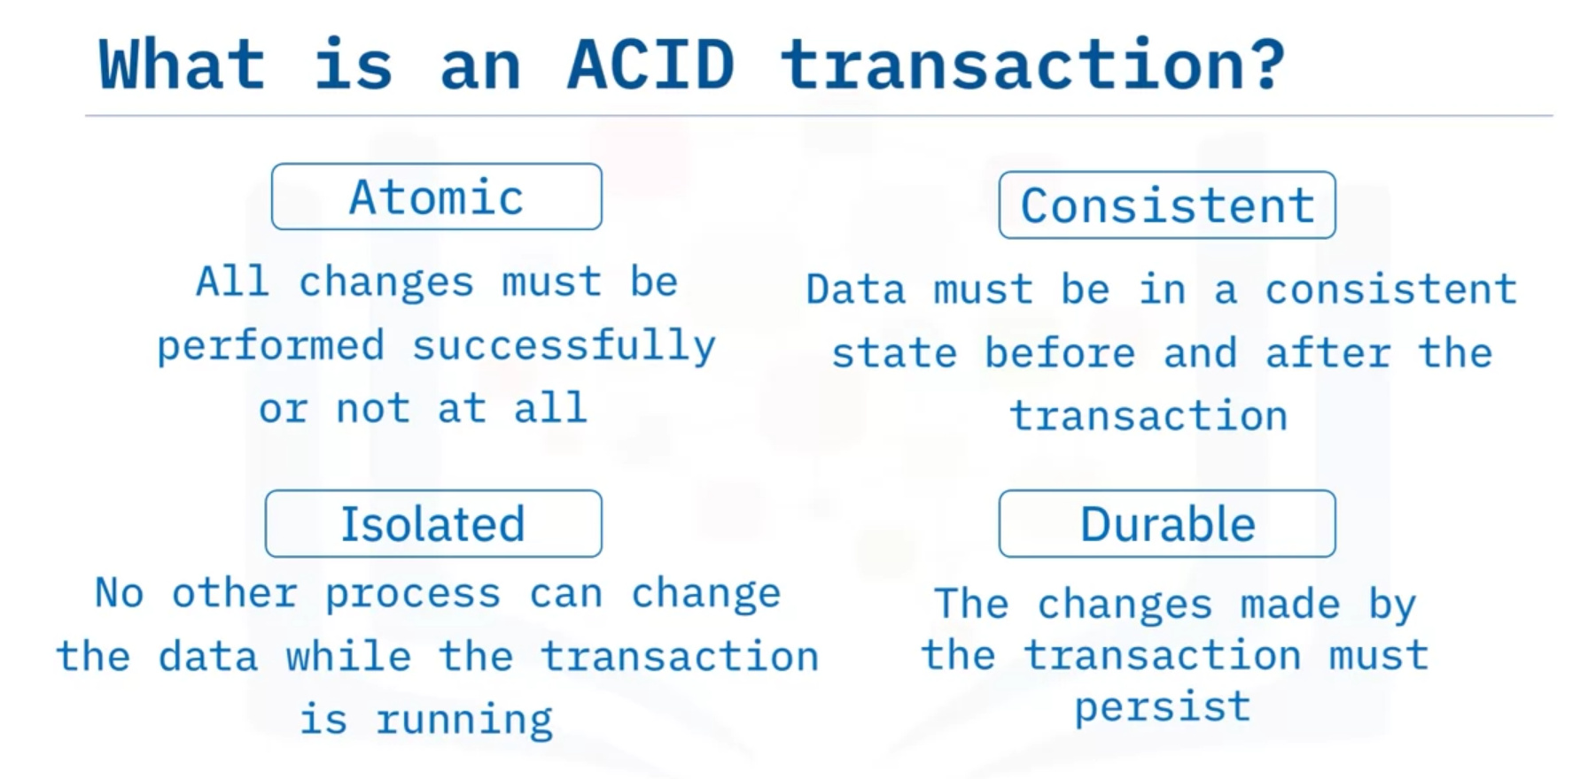

ACID transactions are Atomic - all or nothing, leave the database in a Consistent state, Isolated from any other process that changes the same data, and Durable - the changes they make are permanent.

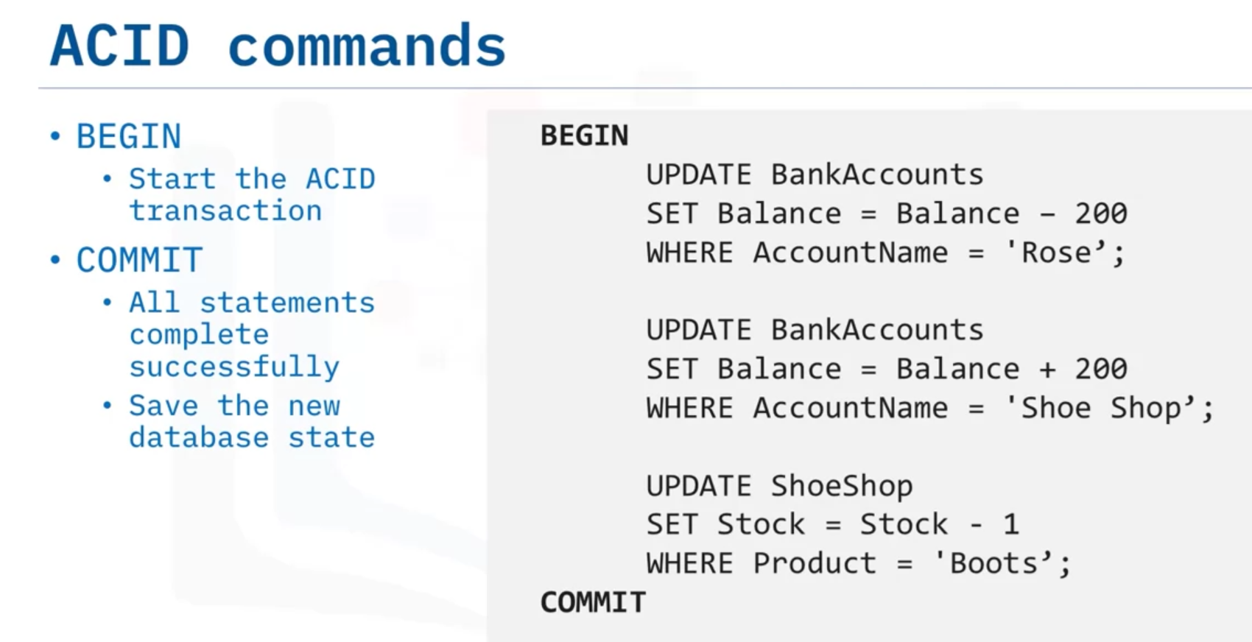

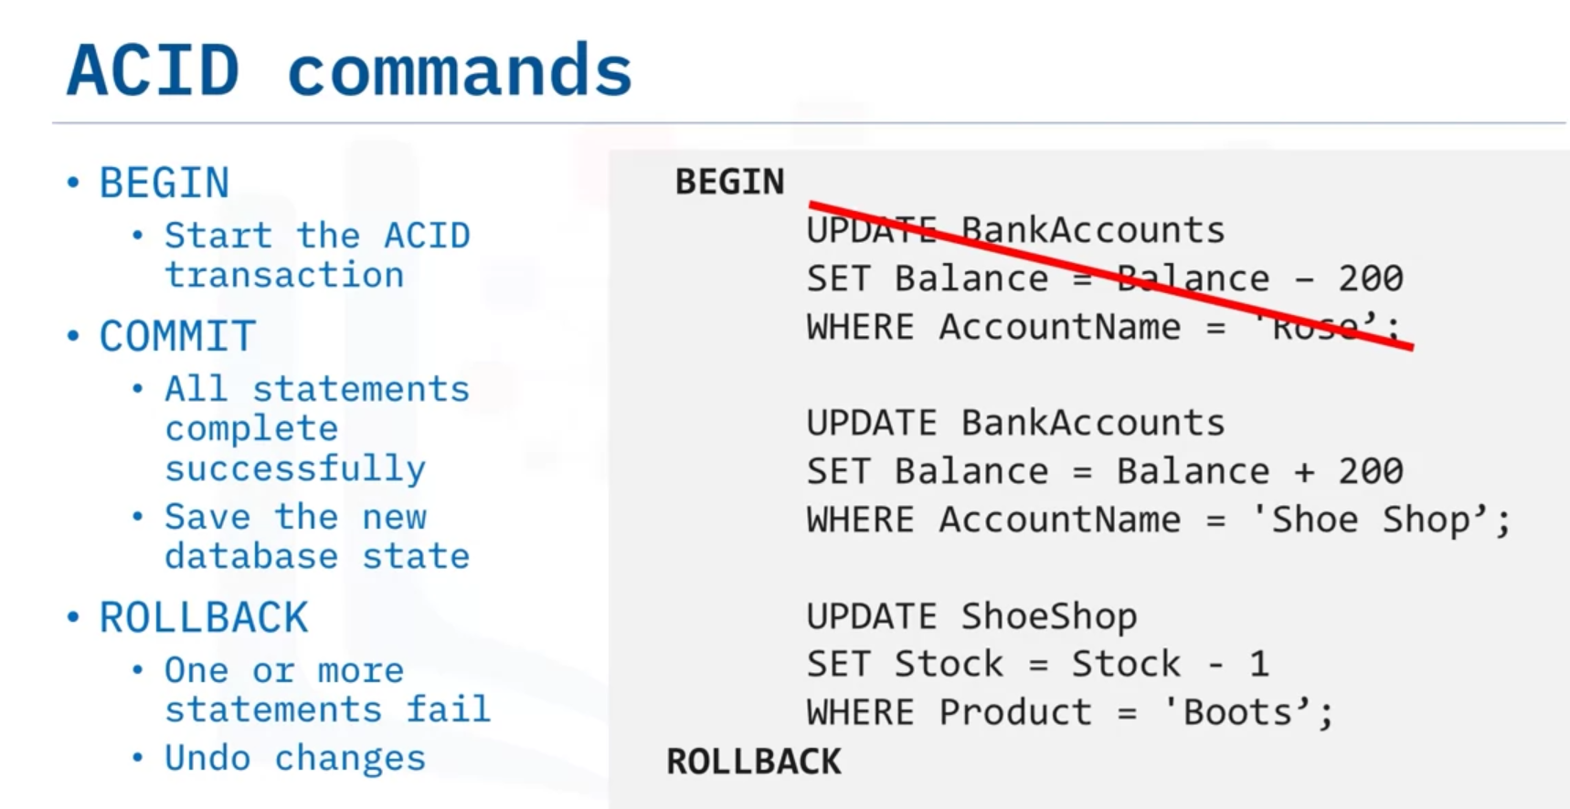

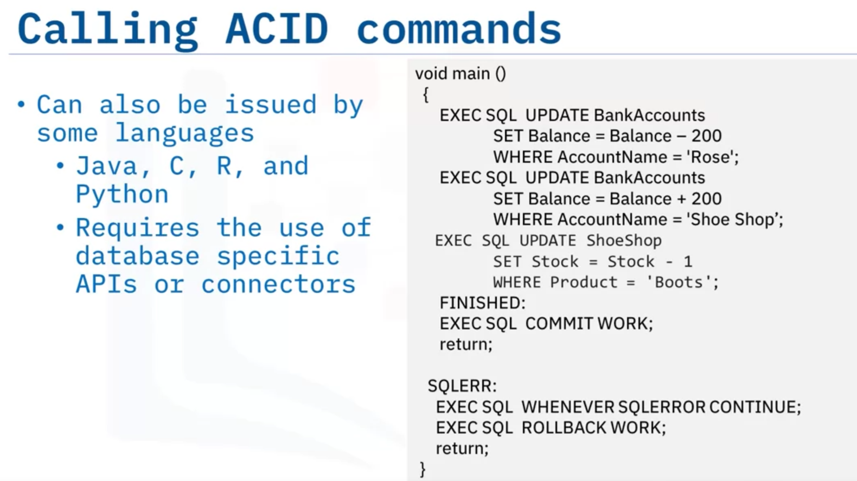

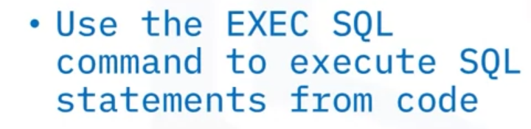

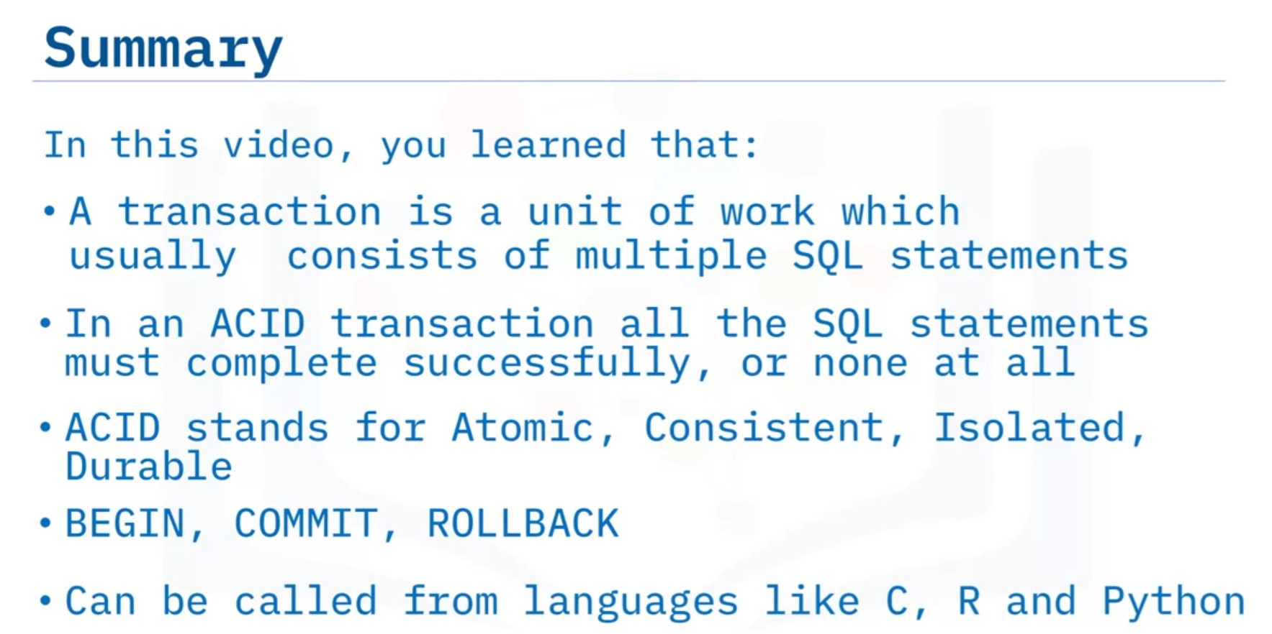

# Summary & Highlights

Congratulations! You have completed this lesson. At this point in the course, you know:

* Views are a dynamic mechanism for presenting data from one or more tables.A transaction represents a complete unit of work, which can be one or more SQL statements.
* An ACID transaction is one where all the SQL statements must complete successfully, or none at all.
* A stored procedure is a set of SQL statements that are stored and executed on the database server, allowing you to send one statement as an alternative to sending multiple statements.
* You can write stored procedures in many different languages like SQL PL, PL/SQL, Java, and C.

**Exercise**

* You will create a stored procedure routine named **RETRIEVE_ALL**.
* This **RETRIEVE_ALL** routine will contain an SQL query to retrieve all the records from the PETSALE table, so you don't need to write the same query over and over again. You just call the stored procedure routine to execute the query everytime.
* To create the stored procedure routine, copy the code below and paste it to the textbox of the **Run SQL** page. Click **Run all**.

